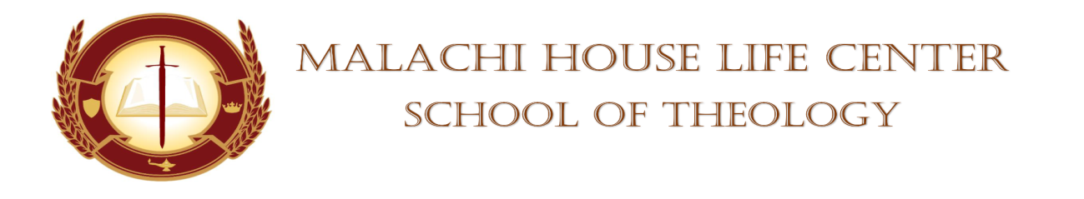

**STUDENT’S CHAPEL SERVICE ASSIGNMENT**

**DATE:** October 14, 2023 **TIME:** 11am

**DEVOTIONAL SERVICE:** Evangelist Leeda Hundley

**PRAYER PERIOD:** Minister Bridgette Sessoms

**SCRIPTURE READING:** Deacon Pearl Smith

**SCRIPTURE SHOWER:** Bro. Kevin Holloman

**OFFERTORY: N/A**

**BLESSING OF THE OFFERING:** N/A

**MASTER/MISTRESS OF CEREMONIES:** Elder Patricia Freeman

**SPEAKERS:**

Sister Adria Lindquist

Evangelist Leeda Hundley

Elder Shaunte Oliver

**SUPPORTOR:** Minister Diane Robinson

**PRAYER FOR THE SPEAKERS**: Pastor Anthony Smart

**FACULTY MEMBER:** Dr, Mickey Collins/Dean Towanna Yizar

**(WHISTLE STOPS)**

**BENEDICTION:** Elder Shaunte Oliver

**Absent:** ___________________________ **Whistle Stops:** _____________________

___________________________ _____________________

___________________________ _____________________

___________________________ _____________________

___________________________ _____________________