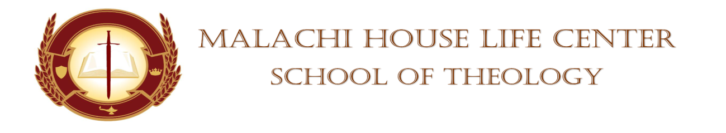

**STUDENT’S CHAPEL SERVICE ASSIGNMENT**

**DATE:** October 28, 2023 **TIME:** 11am

**DEVOTIONAL SERVICE:** Elder Shaunte Oliver

**PRAYER PERIOD:** Deacon Pearl Smith

**SCRIPTURE READING:** Pastor Anthony Smart

**SCRIPTURE SHOWER:** Minister Bridgette Sessoms

**OFFERTORY: N/A**

**BLESSING OF THE OFFERING:** N/A

**MASTER/MISTRESS OF CEREMONIES:** Elder Patricia Freeman

**SPEAKERS:**

Minister Diane Robinson

Evangelist Leeda Hundley

**SUPPORTOR:** Sister Adria Lindquist

**PRAYER FOR THE SPEAKERS**: Deacon Pearl Smith

**FACULTY MEMBER:** Dr. Mickey Collins/Dean Towanna Yizar

**(WHISTLE STOPS)**

**BENEDICTION:** Bro. Kevin Holloman

**Absent:** ___________________________ **Whistle Stops:** _____________________

___________________________ _____________________

___________________________ _____________________

___________________________ _____________________

___________________________ _____________________