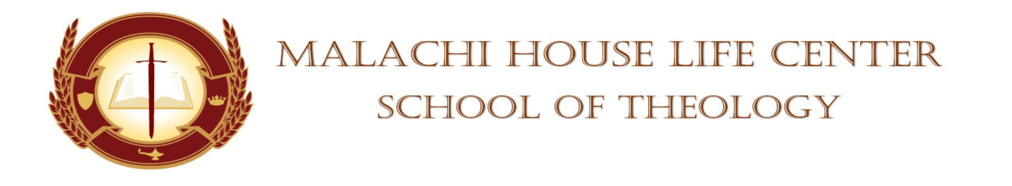

STUDENT’S CHAPEL SERVICE ASSIGNMENT

DATE: November 4, 2023 TIME: 11am

DEVOTIONAL SERVICE: Minister Diane Robinson

PRAYER PERIOD: Minister Bridgette Sessons

SCRIPTURE READING: Sister Adria Lindquist

SCRIPTURE SHOWER: Minister Debra Price

OFFERTORY: N/A

BLESSING OF THE OFFERING: N/A

MASTER/MISTRESS OF CEREMONIES: Elder Patricia Freeman

SPEAKERS:
Bro. Kevin Holloman
Deacon Pearl Smith
Pastor Anthony Smart

SUPPORTOR: Evangelist Leeda Hundley

PRAYER FOR THE SPEAKERS: Elder Shaunte Oliver

FACULTY MEMBER: Dr. Mickey Collins/Dean Towanna Yizar
(WHISTLE STOPS)

BENEDICTION: Sister Adria Lindquist

Absent: ___________________________ Whistle Stops: _____________________
___________________________ _____________________
___________________________ _____________________
___________________________ _____________________
___________________________ _____________________

