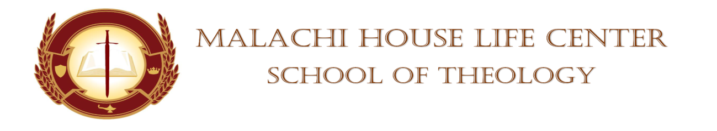

**STUDENT’S CHAPEL SERVICE ASSIGNMENT**

**DATE:** December 16, 2023 **TIME:** 11am

**DEVOTIONAL SERVICE:** Minister Diane Robinson

**PRAYER PERIOD:** Sis. Adria Lindquist

**SCRIPTURE READING:** Pastor Anthony Smart

**SCRIPTURE SHOWER:** Minister Debra Price

**OFFERTORY: N/A**

**BLESSING OF THE OFFERING:** N/A

**MASTER/MISTRESS OF CEREMONIES:** Minister Bridgette Sessoms

**SPEAKERS:**

Bro. Kevin Holloman

Sister Adria Lindquist

Minister Diane Robinson

Evangelist Leeda Hudley

**SUPPORTOR:** Elder Shaunte Oliver

**PRAYER FOR THE SPEAKERS**: Elder Patricia Freeman

**FACULTY MEMBER:** Dr, Mickey Collins/Dean Towanna Yizar

**(WHISTLE STOPS)**

**BENEDICTION:** Minister Bridgette Sessoms

**Absent:** ___________________________ **Whistle Stops:** _____________________

___________________________ _____________________

___________________________ _____________________

___________________________ _____________________

___________________________ _____________________