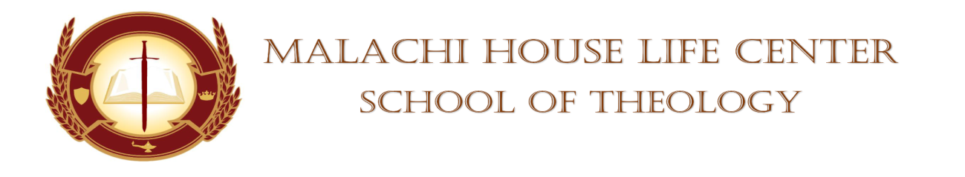

STUDENT’S CHAPEL SERVICE ASSIGNMENT

DATE: April 13, 2024 TIME: 11am

DEVOTIONAL SERVICE: Evangelist Leeda Hundley

PRAYER PERIOD: Deacon Pearl Smith

SCRIPTURE READING: Bro. Kevin Holloman

SCRIPTURE SHOWER: Pastor Anthony Smart

OFFERTORY: N/A

BLESSING OF THE OFFERING: N/A

MASTER/MISTRESS OF CEREMONIES: Elder Patricia Freeman

SPEAKERS:

Bro. Kevin Holloman
Deacon Pearl
Evangelist Leeda Hundley

SUPPORTOR: Elder Shaunte Oliver

PRAYER FOR THE SPEAKERS: Minister Diane Robinson

FACULTY MEMBER: Dr. Mickey Collins/Dean Towanna Yizar
(WHISTLE STOPS)

BENEDICTION: Minister Diane Robinson

Absent: ___________________________ Whistle Stops: _____________________
___________________________ _____________________
___________________________ _____________________
___________________________ _____________________
___________________________ _____________________

