Malachi House School of Theology’s 2020 Graduation Guest Speaker
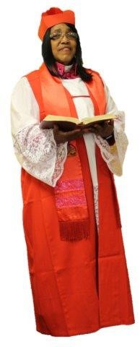
Apostle Brenda Holliday, PhD. is the Founder and President of My Father's House Apostolic School of Ministry located in Williamsburg VA.
Apostle Holliday holds a BA in Biblical Studies, Master’s in Theological Studies and Doctor of Divinity Degree. She has earned a PhD in Theology from Regency Christian College. Also because of her love and care for all people, she is currently pursuing a Masters in Pastoral Counseling/Chaplaincy at Liberty University.
Apostle Holliday has served as the Assistant Pastor of My Father's House Apostolic Outreach Ministries, and she has served as the Pastor of My Father's House Church. In March 2011 she was consecrated as a Bishop, and then on July 15, 2017, she was Affirmed as an Apostle. For many years, she has provided ministry and leadership for churches and ministries, but most of all, Apostle Holliday is a mighty woman of God who has a desire to teach, preach and reach people for Jesus.
"Teach me, Lord, what you want me to do,
And I will obey you faithfully;
Teach me to serve you with complete devotion" Psalm 86:11

You may also join the live stream via MHLC website
www.malachilifecenter.org

